2026 Impact Case Study evaluation
6 May 2026
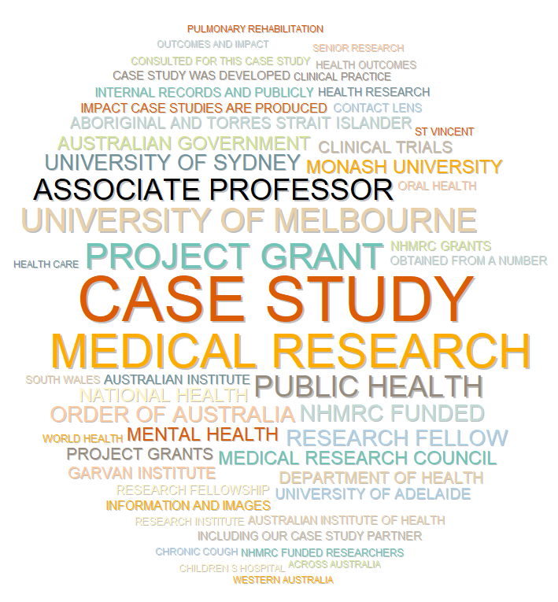
Contents
Executive Summary 3
Introduction 4
Evaluation 5
Case study topics 6
Case study promotion 12
Case study use 16
Discussion 24
Appendices 26
Appendix A – Methodology 27
Appendix B – Case study categories 28
Appendix C – Publicly available references to the case studies 31

Executive Summary
This evaluation assesses NHMRC’s Impact Case Study business activity with a focus on case study topics, promotion and use.

Case study topics
Case study topics reflect diverse pathways to impact, most commonly changes to clinical practice and pharmaceutical development. Case studies span all major health categories and all research activity categories within the UK Health Research Classification System. Case studies draw on health and medical research (HMR) undertaken across many institutions, with a focus on major universities but also including hospitals and medical research institutes. The proportion of women among profiled researchers has increased over time and exceeds half in more recent periods.
Overall, current approaches to selecting case study topics appear fit for purpose and consistent with NHMRC’s objective of demonstrating contribution to improvements in health.

Case study promotion
NHMRC has increased promotion of case studies since earlier evaluations. Analysis of Twitter/X data indicates that engagement with case study posts is similar to most other NHMRC content, though lower than engagement with grant announcements and feature-style posts. Case study tweets tend to include fewer links and less human‑centred language. Revising the style of these posts may improve engagement.

Case study use
Case studies receive similar levels of use to NHMRC Annual Reports and are most commonly accessed via search engines. Users are distributed across Australia and over one quarter are located internationally. Some case studies attract higher and more sustained interest, likely reflecting topic relevance and external referencing. Case studies also add value through reuse and citation in other policy and informational documents.

Overall conclusions
The Impact Case Study business activity is delivering value for NHMRC. It is functioning as intended and supports NHMRC’s accountability and impact objectives.

Introduction
The present evaluation presents analyses of case study content, audience engagement and case study promotion up to 10 October 2025. It also offers recommendations about strategic opportunities to improve case study promotion.
The primary audience for this report is NHMRC’s Executive Board, however the report contains content that may also be interesting to a broader audience including past and possible future case study partner organisations.

Background
As set out on the case study homepage, NHMRC produces Impact Case Studies to demonstrate its contribution to raising the standard of individual and public health throughout Australia. A logic model for the case study business activity is provided in Figure 1.
- Logic model for the Impact Case Study business activity
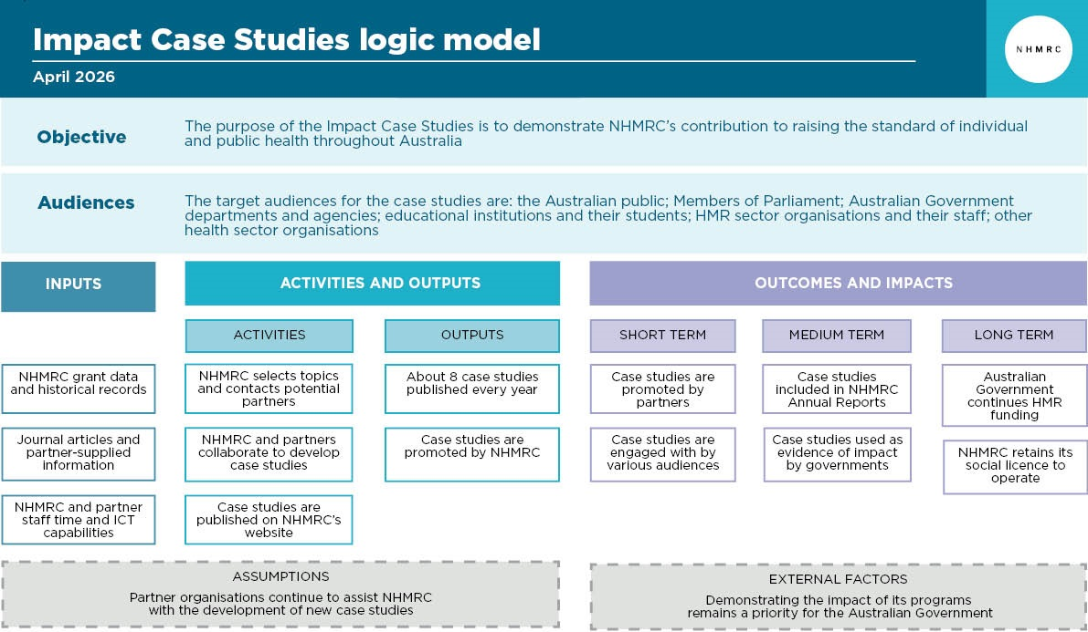
NHMRC commenced developing Impact Case Studies in February 2018 and, as shown in Figure 2, about 8 case studies have been produced every year since that time, with a total of 63 case studies included within this evaluation.
Further details about the case studies, and about the methodology that underpins this evaluation including definitions of key terms related to social media metrics and webmetrics are provided at Appendices A and B.
- Number of case studies produced by year (calendar, financial)
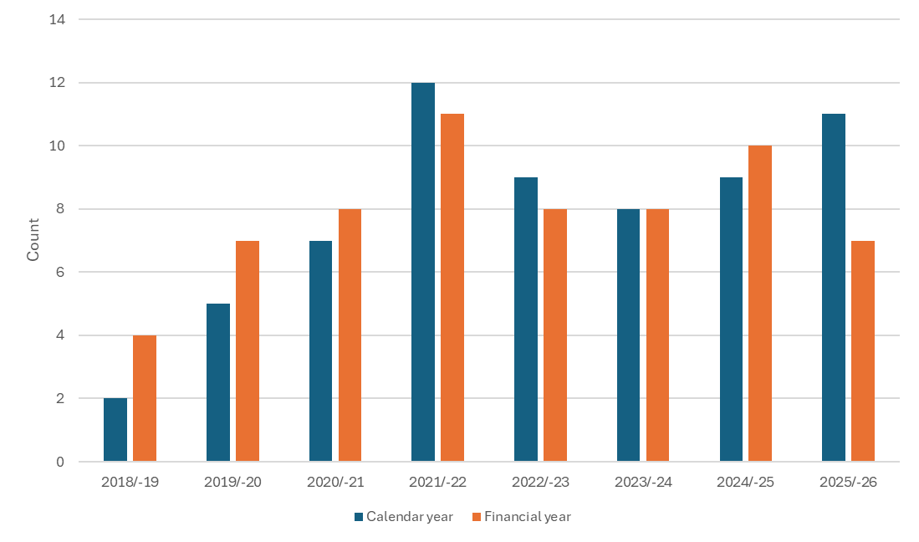

Evaluation
The Impact Case Study business activity has previously been evaluated (in 2021 and 2023). Both previous evaluations recommended that the level of case study promotion be increased. This has taken place, with case studies now routinely promoted using Tracker and more regularly promoted via Twitter/X and other social media.
The 2023 evaluation recommended a content analysis of the previously published case studies. This has taken place, with the present evaluation reporting on some of the data that has been extracted.
Noting that the objective of the case studies is to demonstrate NHMRC’s contribution to raising the standard of health in Australia, the present evaluation examines this objective within the following three areas:
- Case study topics: to what extent are the case study topics representative of the broad range of ways that NHMRC’s activities lead to health improvements?
- Case study promotion: what opportunities exist to improve case study promotion?
- Case study use: what can we know about who is using the case studies and why?

Case study topics
A question that is periodically asked about the case study business activity is ‘how are the topics of the case studies chosen?’ Because a case study may be understood as a public statement that NHMRC values a certain type of research and – implicitly – the researchers and institutions involved, it is important that the case studies be broadly representative of the range of types of research that NHMRC funds.

Pathways to impact
As shown in Figure 3, changes to clinical practice and the development of pharmaceuticals are two key impacts described in the case studies. Because case study topics are specifically chosen to demonstrate health impacts, it is only occasionally that a case study focuses on knowledge impacts, which is why this category includes the smallest number of case studies.
- Count of case studies by pathway to impact
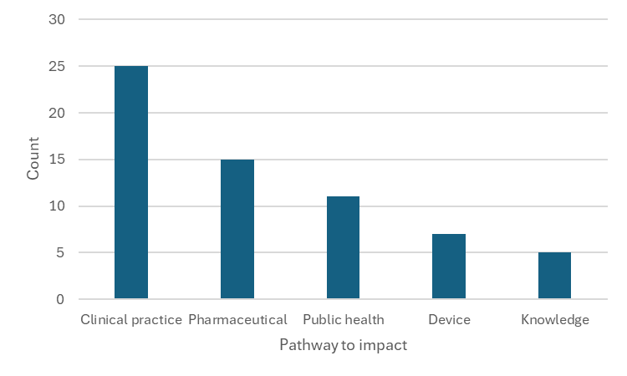
Compared to the Broad Research Areas (BRAs) of all NHMRC grants since 1999, the grants underpinning case study research are more often categorised as health services and public health, and less often as basic research, with clinical medicine grants being about equally represented (refer Figure 4).
Notwithstanding the above, and as shown in Figure 5, most health interventions described within the case studies are biomedical and operate at the level of molecules, cells or tissues, rather than at the level of the whole individual or at the level of society.
- Proportion of case study underpinning grants and all grants by BRA since 1999
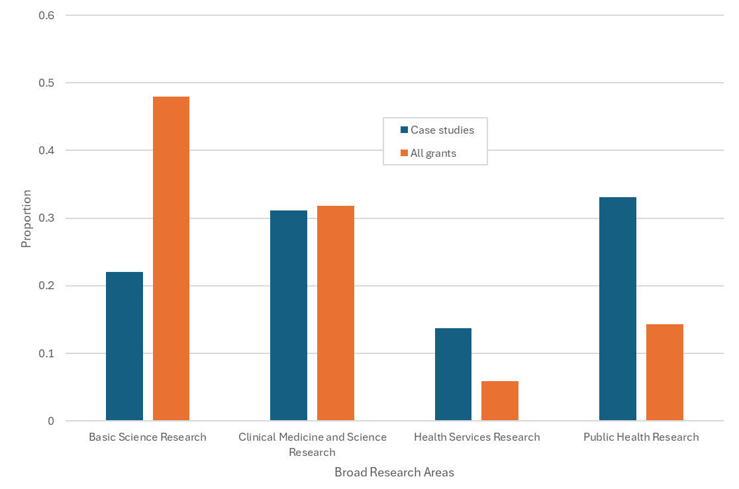
- Count of case studies by Scale of Life category
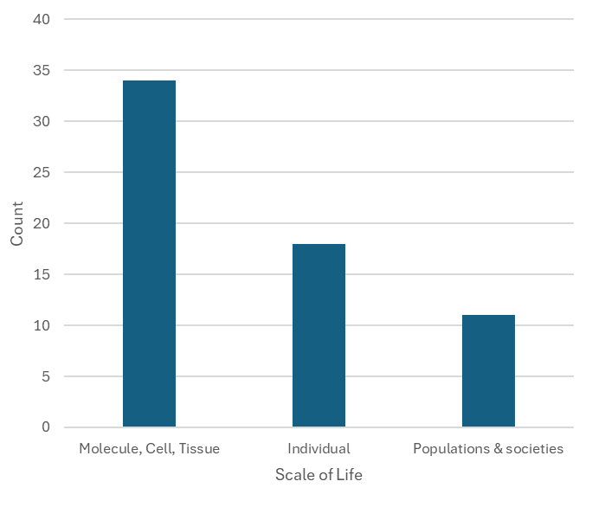

Health categories
As shown in Figure 6, when UK Health Research Classification System (HRCS) health categories are assigned to each case study, the most common topics are infection, reproduction and childbirth, and respiration. Of the 20 standard top-level HRCS health categories, and at the time of publication of this report, case studies had been drafted within all of them.
- Count of primary HRCS Health Category for each case study
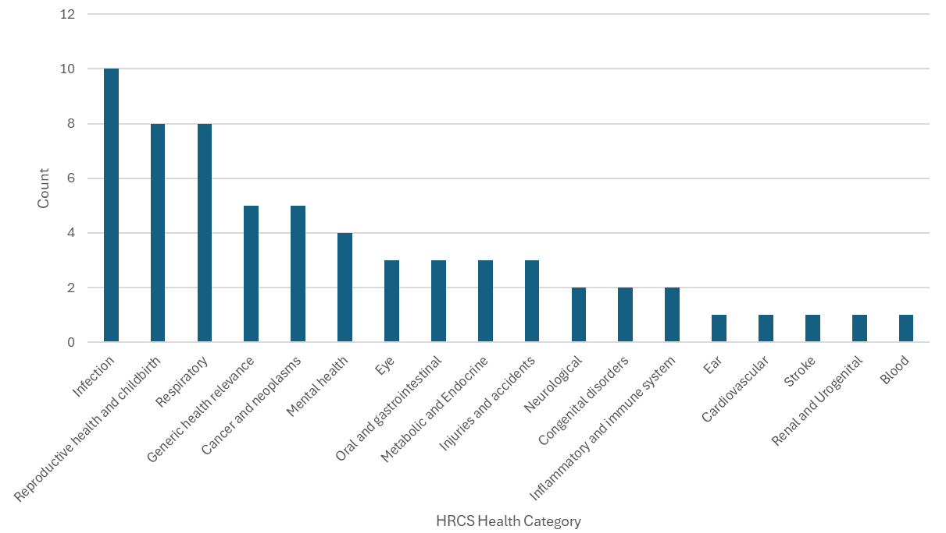

Research activities
The HRCS classification system also includes a set of 8 research activity categories. As shown in Figure 7, case studies have been developed within each of them, however more than half of the case studies fall into the categories of development and evaluation of treatments, and detection, screening and diagnosis.
- Count of primary HRCS research activities for each case study
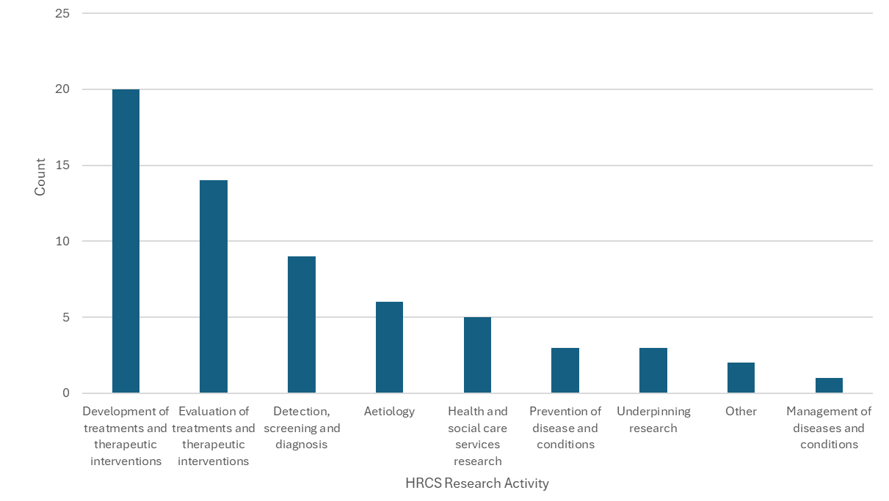

Population groups
The Australian Institute of Health and Welfare (AIHW) collects statistics for 11 population groups. Figure 8 classifies each case study according to the most relevant AIHW population group, or else uses ‘general population’ where no sub-population is deemed to be relevant. Older people, children and youth, and mothers and babies are the most prevalent sub-populations relevant to the case studies, while about one quarter of case studies relate to the general population.
- Count of case studies by focus on primary AIHW health population group
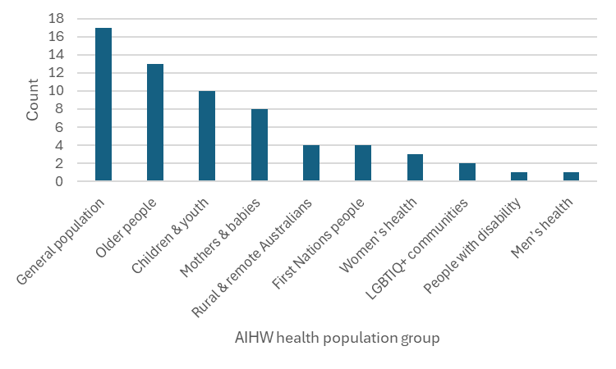

Timeline durations
The poster for each case study includes a timeline, and by subtracting the year of the first event shown on the timeline from the year of the last event, a total duration in years may be calculated for each case study. As shown in Figure 9 this data follows an approximately bell-shaped distribution with a modal (most common) duration of 20-29 years.
- Count of case study timeline duration periods
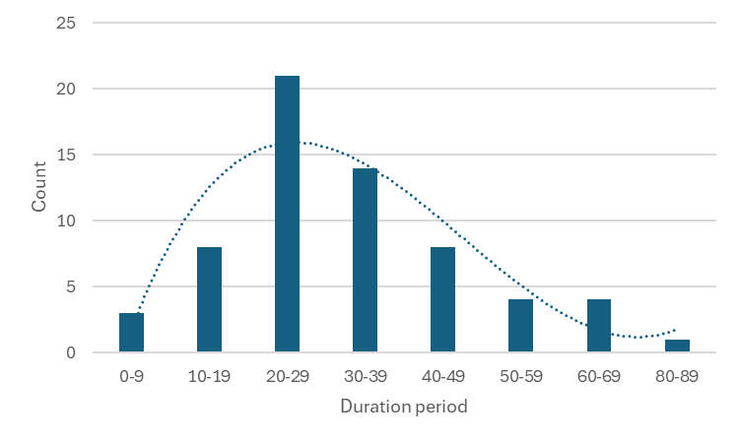

Researcher gender
Each case study includes a profile section wherein are listed the names and career histories of the key researchers responsible for the impact. As shown in Figure 10, the proportion of women researchers profiled within the case studies has been increasing linearly over the time periods shown in the figure. For the period of the 2010s, this proportion of profiled female researchers exceeds 50%.
- Proportion of female researchers profiled in case studies over time
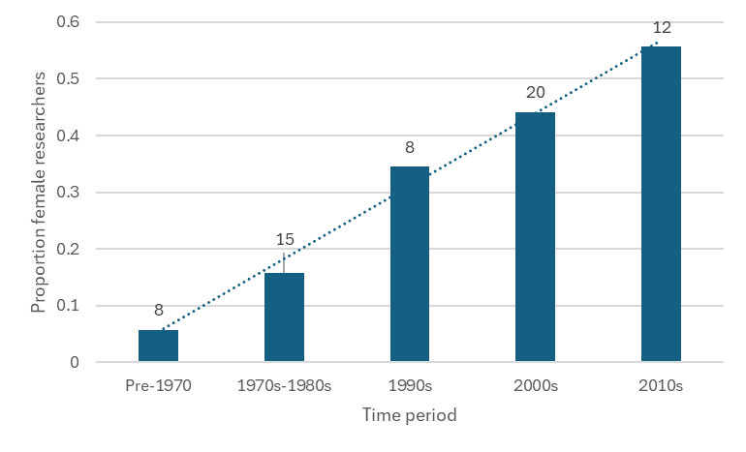

Researcher affiliation
The profile section includes the past and present institutional affiliations of the profiled researchers, and as shown in Figure 11, profiled researchers are most likely to have been educated at, or to have worked at, a major university. That said, hospitals are also prominently listed, as are some key medical research institutes.
- Count of mentions of research institutions within case study profile text
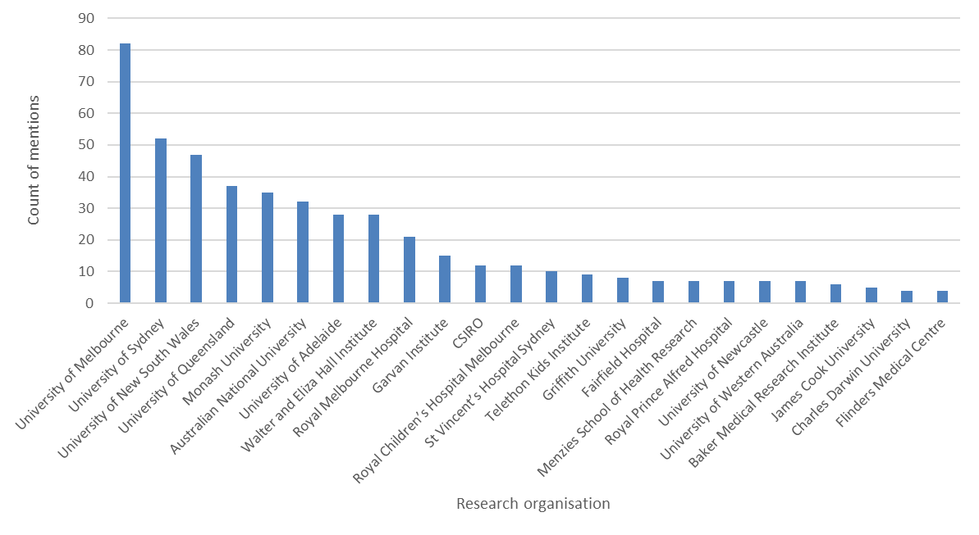
Findings
• The case studies cover a broad range of topics across a broad range of time periods.
• Gender equality has been achieved among profiled researchers in recent case studies.

Case study promotion
Once they have been published, case studies are then promoted by NHMRC’s media team. Key forms of promotion include items within NHMRC Tracker and tweets - short messages posted by NHMRC’s media team on the social media platform Twitter/X.
This section provides analyses related to NHMRC’s case-study and other Twitter/X postings during the calendar years 2018-2025.
During the calendar years 2018-2025, NHMRC posted over 2,100 tweets, or over 270 per year or about 5 per week. These tweets may be grouped into different categories, as shown in Figure 12.
The majority of tweets (about 60%) are concerned with providing news about NHMRC corporate activities (e.g. News, Tracker, grant announcements) while the remainder provide information about the successes and activities of researchers (e.g. InFocus articles, Awards, Speaking of Science, case studies and 10 of the Best).
- Tweets per year by tweet content type
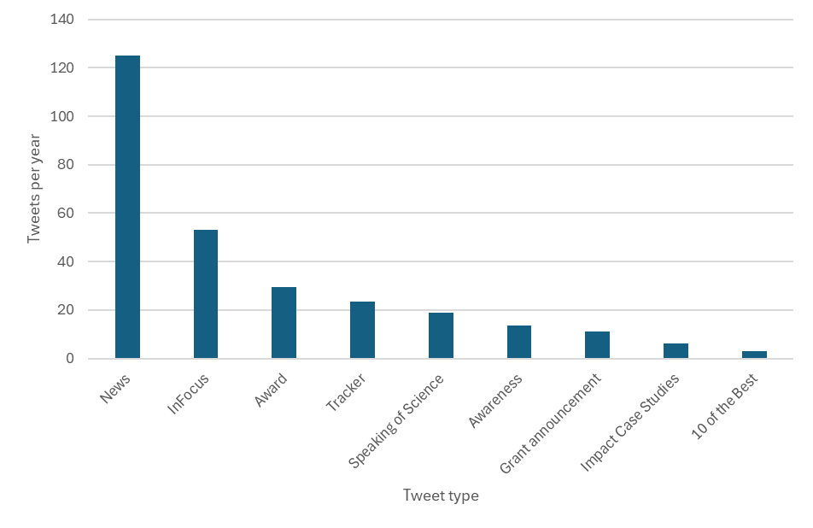

Tweets engagement by tweet type
Some NHMRC tweet types receive much more engagement than do others. As shown in Figure 13, grant announcements receive about an order of magnitude more engagement than most other tweet types, with 10 of the Best coming second.
- Engagements per tweet by tweet content type
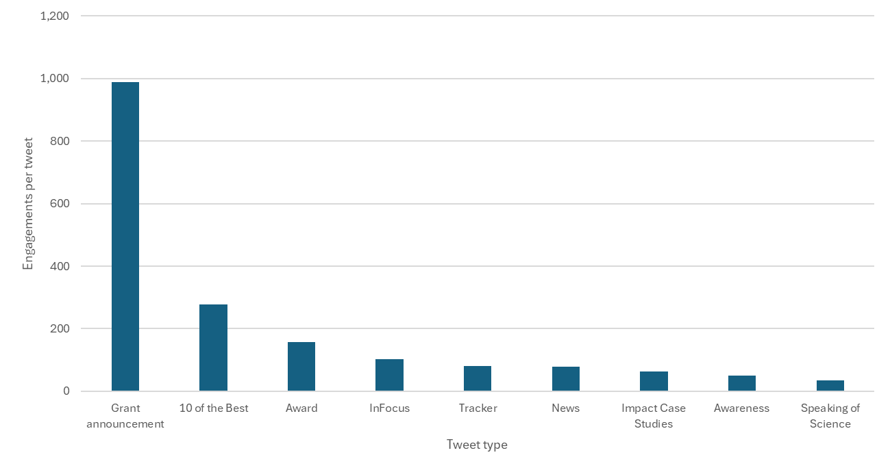
The chart above suggests that key users of NHMRC tweets are likely to be Australian health and medical researchers and research organisations, who compete for NHMRC grants and who are therefore particularly interested in grant announcements.

Case study tweets versus other types of tweets
There are two obvious ways in which case study tweet content currently differs from other tweet content.
First, as shown in Figure 14, case study tweets have tended to contain fewer links (e.g. http), hashtags and @mentions than have other tweet types. Since such links provide an opportunity for users to engage, the relative absence of such content tends to reduce possible audience engagement.
A second difference relates to the relative human-centricity of the language contained in the tweet. As shown in Figure 15, the language found in 10 of the Best tweets tends to be much more human-centric than the language found in case study tweets.
Human-centric language includes names of researchers, names of health population groups, direct quotes from researchers and emotive terms. Emotive terms found in the 10 of the Best tweets include: ‘We couldn’t wait’, ‘NHMRC is proud’, ‘a tribute to the researchers’, ‘research success story’, ‘enhancing the future’, ‘celebrating the launch’, ‘extraordinary stories’, ‘fascinating research’, ‘a legacy of safe maternity care’, ‘on a quest’, ‘the impacts of trauma’.
By contrast, case study tweets tend to include more business language, including terms such as: ‘NHMRC-funded’, ‘case study’, ‘publication’, ‘edition’, ‘flagship’, ‘guidelines’, ‘consortium’, ‘grant’, ‘project’, ‘program’, ‘register’, ‘policy’, ‘practice’ and ‘media release’.
- Presence of text type by tweet content type
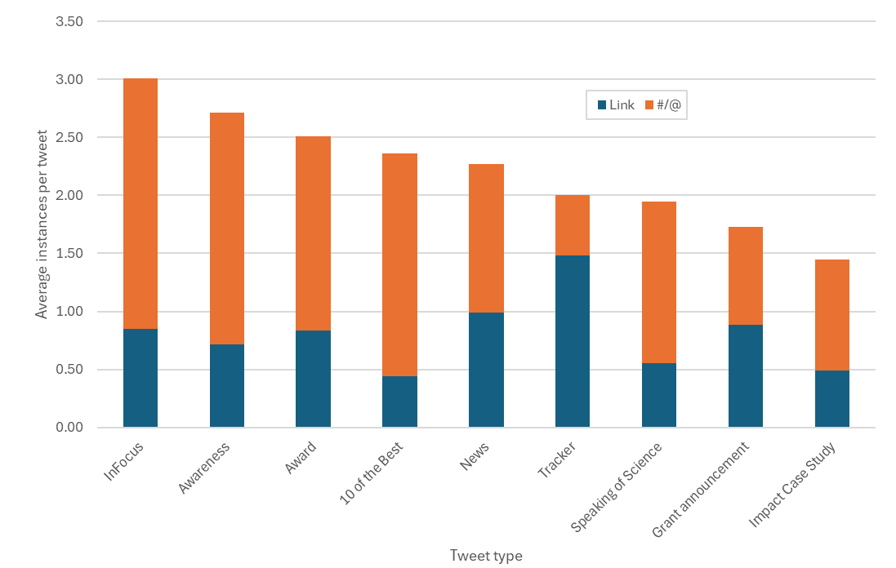
- Proportional presence of human-centric or business language by tweet type
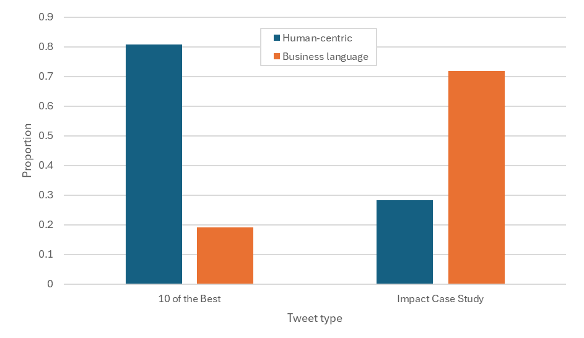

Findings
• User engagement with case study tweets is of a similar level to engagement with most other types of tweets besides grant announcements and 10 of the Best.
• Amending the text of future case study tweets to increase their emotivity and human-centric content and to include more links may increase the level of user engagement.

Case study use
This section provides an analysis of available web-metrics relating to the usage patterns of the published case studies. The data used for this analysis covers the period 18 April 2023 to 17 November 2025, being the total data available at the time when this component of the analysis was conducted.

Pageview comparison with other NHMRC publications
As shown in Figure 16, individual case studies receive about the same number of pageviews and users as do the NHMRC’s Annual Reports, but they receive about 25% fewer views/users than do News Centre articles.
- Views and active users for three types of webpages
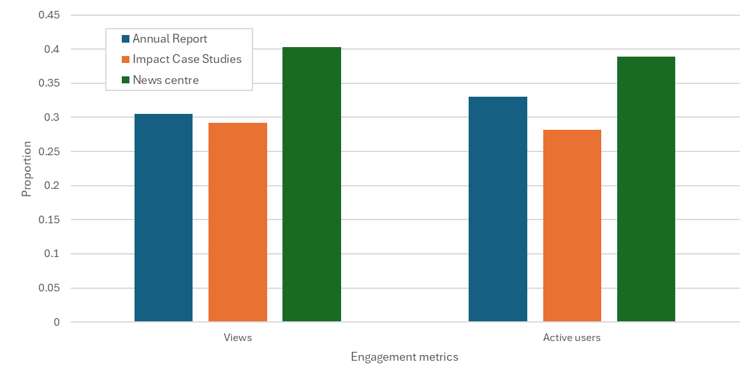

As shown in Figure 17, about one third more users of case studies (as opposed to Annual Reports or News Centre items) found them using a search engine. News Centre items are much more likely than are case studies to be found as a result of a link within social media.
- Primary access channels to three types of webpages
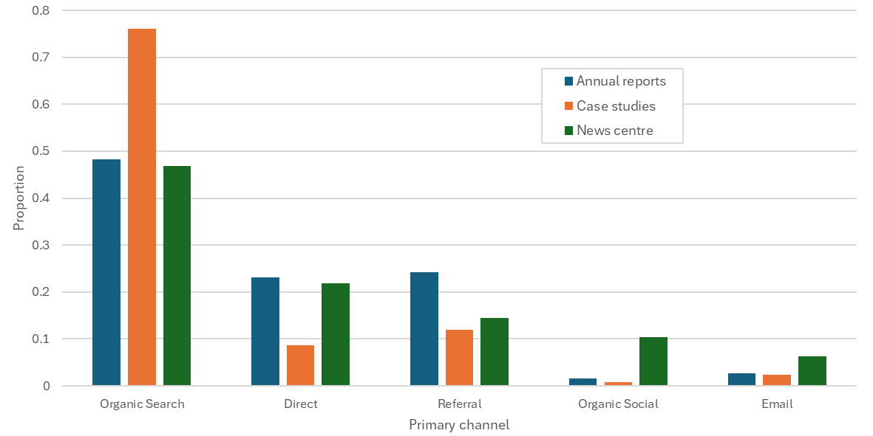

Viewer location
As shown in Figure 18, while most case study users come from Oceania, over one quarter live in other parts of the world.
- Case study pageviews by global region
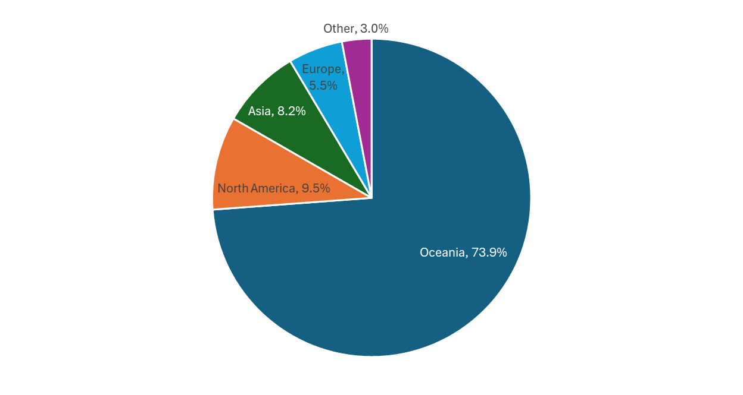
As shown in Figure 19, there are more case study users in some large overseas cities than there are in some small Australian cities. This international usage is presumably a result of the large proportion of case study users from any location who find the case studies as a result of search engine queries (as per Figure 17).
- Case study pageviews by city
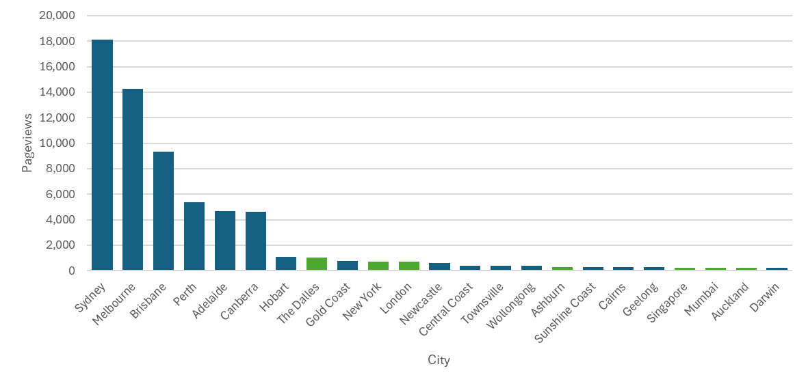
As shown in Figure 20, when adjusted for population, case study use is very similar across Australia’s states and territories, with the exception of ACT which experiences use about 5 times the average level of the other states/territories. Some proportion of these users are located within NHMRC itself.
- Case study pageviews per capita by state/territory
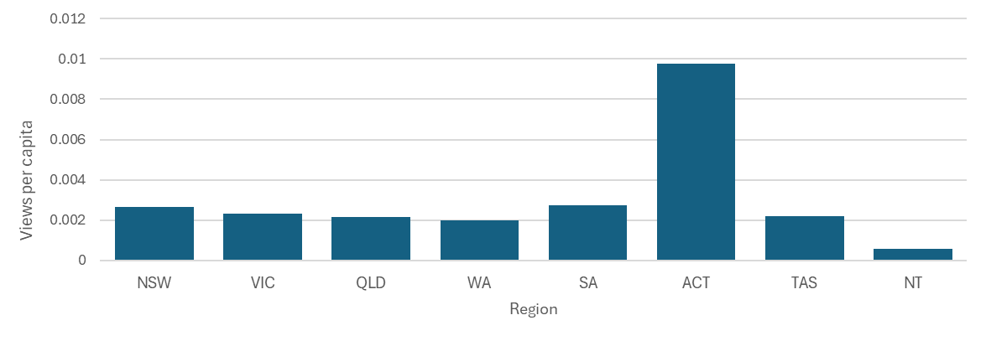

Views by case study and topic
As shown in Figure 21, some case studies receive many more views per day than do others.
The median (middle) number of pageviews per day across all case studies published at the time of this analysis was 2.4. The case studies receiving views above this level are shown in Figure 21, while those receiving fewer than this value are shown in Figure 22.
- Case study pageviews per day by case study – above median
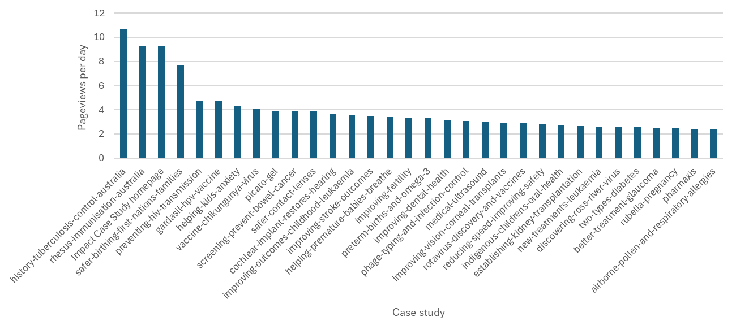
- Case study pageviews by case study – below median
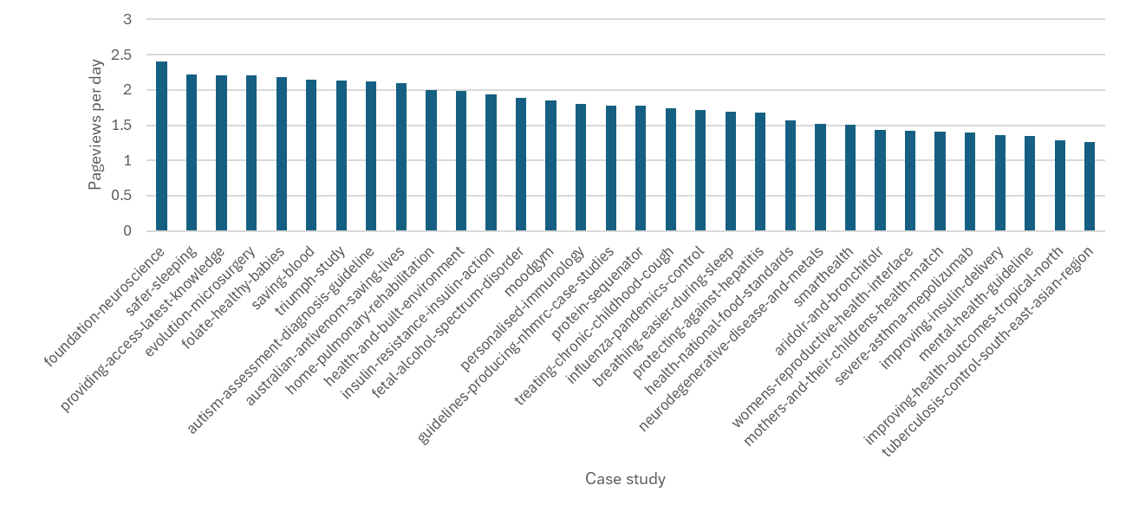
The 2023 case study evaluation investigated the question of why some case studies are viewed more than others and concluded that this was most likely because some topics are searched for more often than others. Another reason may be that some case studies have been referred to by other websites. For example, the long-term above-average interest in the 2020 History of tuberculosis control in Australia case study may be because it is referenced and quoted from the Museums Victoria website.
Notably, a number of case studies were referred to on page 3 of the draft National Health and Medical Research Strategy (refer Figure 23). Some other known public references to the case studies are provided at Appendix C.
Given that some topics are searched for more than others, one possible mechanism for increasing case study usage may be to include more end-user, consumer and community stories in the case studies as such stories may relate to topics of greater public interest.
- Image from the draft National Health and Medical Research Strategy 2026-2036
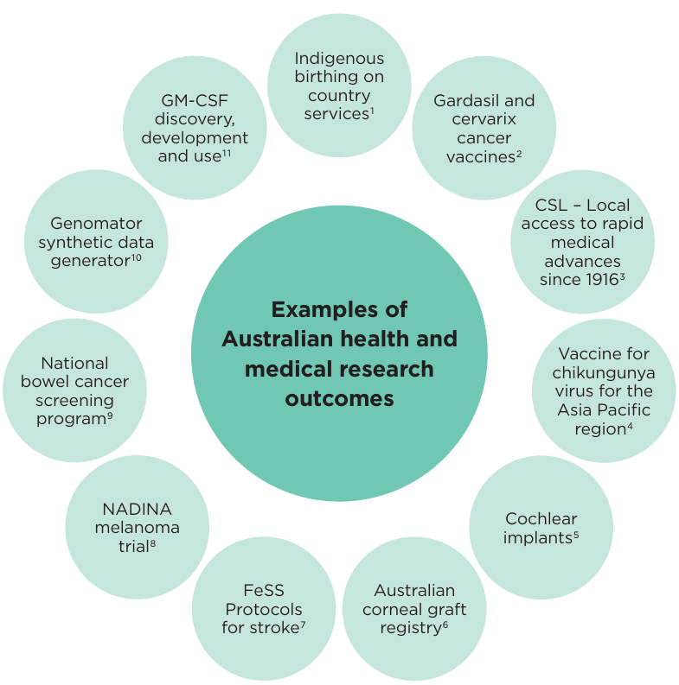
Because case studies have different topics, they may also be of interest to people in locations relating to those topics.
Figure 24 shows those case studies that received more than two standard deviations above the mean of pageviews in each capital city. As is evident within this figure, an obvious connection often exists between the state/territory where the case study is most often used and the location of organisation(s) that partnered to develop it (shown on top of each bar).
- Top proportions of pageviews received by case studies for users in each capital city
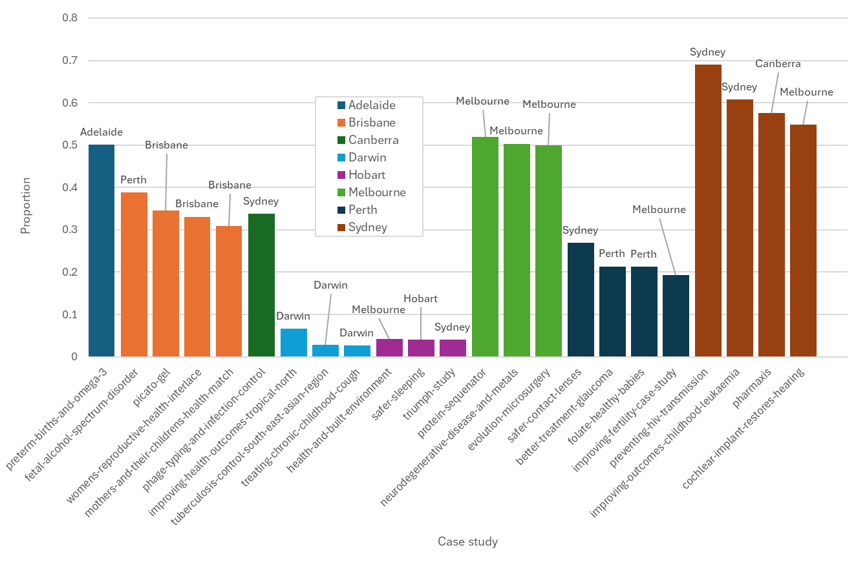

Viewer by access channel and usage platform
While (as previously discussed) users may find case studies in different ways, it is also the case that the way that users find a case study is connected to the case study itself. Figure 25 shows the top 5 case studies for each type of access channel (as previously defined). Notably, there are several case studies that appear in this figure more than once (as indicated on the chart).
These results suggest that it was the case studies themselves (rather than their topics) that were of particular interest to users, and therefore that the users had received some kind of promotion concerning those case studies.
- Top five pageviews by case study by access channel
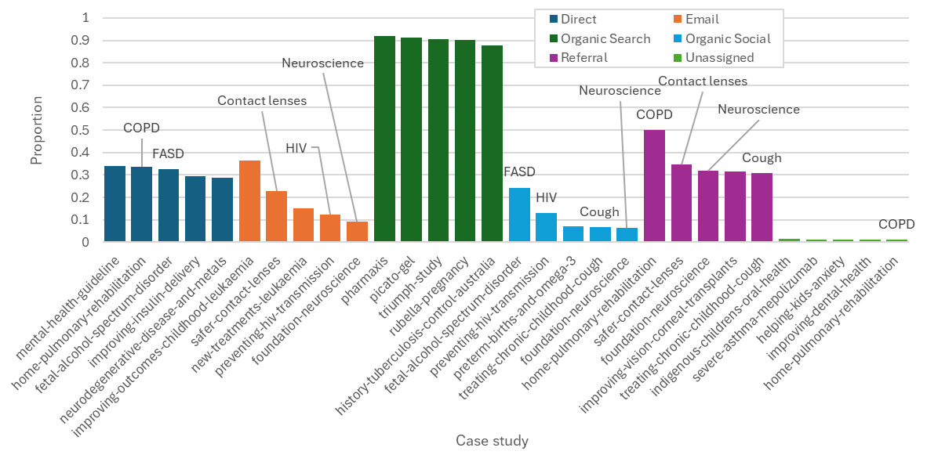
Case study users may access them from different types of computer platforms. Figure 26 shows the top 10 case studies per platform. Apple computers are often used within home and educational contexts, and mobile platforms are most often used at home or ‘on the go’. Across these two platforms, at least half of the case studies have direct relevance to pregnancy and children (as indicated by an asterisk in the graph), suggesting that the case studies were being used as part of personal information gathering by members of the public.
- Top 10 proportionate pageviews for case studies for each software platform
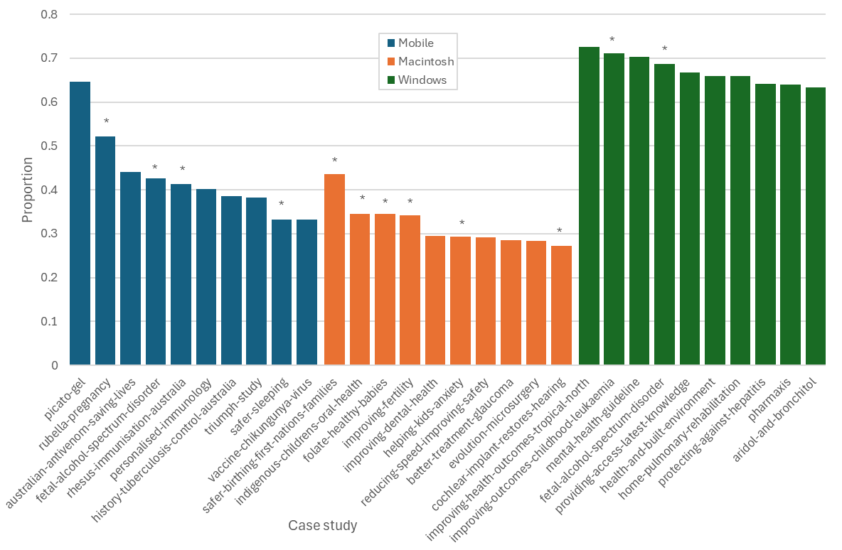
Case studies relating to pregnancy or children marked with an asterisk
Findings
• At present, case study users are most likely to find them organically.
• Case studies are valuable not only because they are read directly, but also because they are referred to within other government documents and webpages.
• Some case studies are being used because users already knew they existed. Increased social media promotion might increase the proportion of case studies found in this way.
• Another approach may be to include more end-user, consumer and community stories in the case studies.

Discussion
The analyses above provide reassurance that the case study business activity is delivering value for NHMRC and also suggest steps that could be taken to improve performance.
The analyses relating to case study topics indicate that case studies have been developed covering a broad range of topics, a broad range of research institutions and an increasingly balanced collection of researchers by gender. Therefore, the range of processes used to underpin the selection of case study topics are ‘fit for purpose’ and do not apparently require any alteration.
The analyses relating to case study use suggest that the case studies are being utilised by members of the general public who are interested in the case study topics. Users are located all over the world and across Australia.
The analyses relating to case study promotion indicate that opportunities exist to improve promotion of the case studies. For example, tweets about the case studies could be drafted to be more attractive to readers. When the case studies are referred to within other online documents (e.g. National HMR Strategy) as not only does this demonstrate their value but it also increases the number of people who are aware of them.

Appendices

- Methodology
The scope of the present evaluation includes all case studies produced up to and including Safer contact lenses, which was published on 10 October 2025, and which was the most recent case study to have been published when data collection for the evaluation began. The full list of these case studies is provided in Appendix B.
The cover image of this report is a word cloud based upon the text of all case studies up to and including Safer contact lenses. This image was generated using Provalis Wordstat software.
The webmetric data analysed in this report was obtained from Google Analytics and covers the period 18 April 2023 to 17 November 2025 inclusive.
The Twitter/X data analysed in this report was obtained from Hootsuite. The data used for this analysis covered the 2018-2025 calendar years, inclusive.
To allow different web- or Twitter-metrics to be placed on the same scale despite being reported using different units and/or possessing significantly different scales (depending upon the context), many analyses compare proportions rather than the original raw numbers. The approach used for rescaling involved all the values for each variable being summed, and then each value being re-presented as a fraction of that total sum.
Case studies largely consist of text. All case study text is captured within a case study database, as are categorisations of the text. A ‘first approximation’ approach was used to assign case studies to Australian Institute of Health and Wellbeing (AIHW) population groups, health and other categories.

Background on tweeting
Tweets can be up to 280 characters in length and can include text as well as emojis, images, videos, GIFs, links and polls. They frequently include hashtags (#), which help to categorize tweets by topic (e.g. #ClimateChange), and mentions (@), which allow other users to be tagged (e.g. @username).
NHMRC tweets are public so anyone can see them if they have access to a Twitter app.
There are a range of ways that a user can engage with or respond to a tweet, including:
- Like – showing approval or interest by clicking the heart icon
- Reply – responding directly to the tweet with a public comment
- Repost (‘retweet’) – sharing the tweet with their own followers, either as-is or with added commentary
- Hashtag exploration – clicking a hashtag to see all tweets using it
- Media tab – browsing only images and videos from a tweet or profile.

Background on webmetrics
A pageview is counted every time a page loads or reloads. If the same user refreshes a page 5 times, that’s 5 pageviews. Users are counted as unique individuals (based on cookies, devices, and Google’s identity signals). The same person visiting multiple pages or returning later is still one user (within the reporting period). Engagement time measures how long the site was actively in focus. Time is only counted when the page is in the foreground and the user is active (not idle or backgrounded).
It is not possible to determine, from the data available, precisely where all pageviews originate from. Many organisations (both Australian and overseas) use cloud platforms such as AWS, Azure and Google Cloud. Pageview requests may be routed through overseas data centres and since analytics tools usually geo locate by IP address this can mean that pageviews are attributed to data centres in the US, Europe, or Asia even when the ultimate user does not reside there.
Traffic may arrive at a case study in a number of ways as follows:
- Organic Search: Traffic that arrives when users click on search engine links.
- Direct: Traffic arriving from a bookmark or a link within a document.
- Referral: Traffic that arrives when a user clicks a hyperlink on another webpage (excluding search engines and social platforms).
- Organic Social: Traffic arriving from links on social media platforms such as Facebook, LinkedIn, Twitter or Instagram.
- Email: Traffic generated when users click links in email messages (such as Tracker).

- Case study categories

# | Publication date | Full title | Pathway to Impact | UK HRCS health categories | AIHW Population Group
1 | 16-Dec-18 | Picato gel | Pharmaceutical | Cancer and neoplasms | Older people
2 | 16-Dec-18 | Aridol and Bronchitol | Pharmaceutical | Respiratory | Children & youth
3 | 18-Mar-19 | The TRIUMPH Study | Clinical practice | Cardiovascular | Older people
4 | 4-Apr-19 | Pharmaxis | Pharmaceutical | Respiratory | Children & youth
5 | 18-Jul-19 | SMART Health | Device | Generic health relevance | Rural & remote Australians
6 | 27-Nov-19 | Neurodegenerative disease and metals | Pharmaceutical | Neurological | Older people
7 | 28-Nov-19 | Severe Asthma: Mepolizumab | Pharmaceutical | Respiratory | General population
8 | 25-Feb-20 | Fetal Alcohol Spectrum Disorder | Public health | Congenital disorders | First Nations people
9 | 7-Apr-20 | History of TB control in Australia | Public health | Infection | General population
10 | 26-Jun-20 | Womens’ Reproductive Health (InterLACE) | Knowledge | Reproductive health and childbirth | Women’s health
11 | 26-Jun-20 | Mothers’ and their Children's Health (MatCH) | Knowledge | Reproductive health and childbirth | Mothers & babies
12 | 26-Aug-20 | Tuberculosis control in the South-East Asian Region | Clinical practice | Infection | Rural & remote Australians
13 | 16-Oct-20 | Autism Assessment and Diagnosis Guidelines | Clinical practice | Mental health | Children & youth
14 | 20-Nov-20 | Australian antivenom saving lives | Pharmaceutical | Injuries and accidents | Rural & remote Australians
15 | 6-Jan-21 | Improving Health Outcomes in the Tropical North | Clinical practice | Infection | First Nations people
16 | 8-Jan-21 | Folate and healthy babies | Public health | Congenital disorders | Mothers & babies
17 | 27-Apr-21 | Influenza pandemics and their control | Pharmaceutical | Infection | Older people
18 | 13-May-21 | Rubella and pregnancy | Pharmaceutical | Infection | Mothers & babies
19 | 17-May-21 | Health and national food standards | Public health | Generic health relevance | General population
20 | 9-Jul-21 | Medical ultrasound | Device | Reproductive health and childbirth | Mothers & babies
21 | 16-Jul-21 | Indigenous children's oral health | Clinical practice | Oral and gastrointestinal | First Nations people
22 | 30-Jul-21 | Helping GPs care for our mental health | Clinical practice | Mental health | General population
23 | 20-Aug-21 | Reducing speed, improving safety | Public health | Injuries and accidents | General population
24 | 24-Sep-21 | Personalised Immunology | Pharmaceutical | Inflammatory and immune system | Women’s health
25 | 17-Dec-21 | A revolution in protein sequencing | Device | Generic health relevance | General population
26 | 24-Dec-21 | Saving blood, saving lives | Clinical practice | Blood | General population
27 | 17-Mar-22 | A safer infant sleeping position | Public health | Respiratory | Mothers & babies
28 | 8-Apr-22 | MoodGYM | Clinical practice | Mental health | Children & youth
29 | 11-Apr-22 | Improving Fertility | Clinical practice | Reproductive health and childbirth | Women’s health
30 | 4-May-22 | The cochlear implant restores hearing | Device | Ear | People with disability
31 | 1-Jul-22 | Improving insulin delivery | Clinical practice | Metabolic and Endocrine | Children & youth
32 | 1-Jul-22 | Safer birthing for First Nations families | Clinical practice | Reproductive health and childbirth | First Nations people
33 | 27-Oct-22 | Two types of diabetes | Knowledge | Metabolic and Endocrine | Older people
34 | 4-Nov-22 | Breathing easier during sleep | Device | Respiratory | Men’s health
35 | 7-Nov-22 | Insulin resistance, insulin action | Clinical practice | Metabolic and Endocrine | Older people
36 | 8-Feb-23 | Protecting against hepatitis | Pharmaceutical | Infection | LGBTIQ+ communities
37 | 1-May-23 | At-home pulmonary rehabilitation | Clinical practice | Respiratory | Older people
38 | 26-May-23 | GARDASIL - the HPV vaccine | Pharmaceutical | Cancer and neoplasms | Children & youth
39 | 3-Aug-23 | Airborne pollen and respiratory allergies | Public health | Respiratory | General population
40 | 16-Aug-23 | Health and the built environment | Public health | Generic health relevance | General population
41 | 23-Aug-23 | Treating chronic childhood cough | Clinical practice | Respiratory | Children & youth
42 | 4-Oct-23 | Phage typing and infection control | Clinical practice | Infection | General population
43 | 4-Oct-23 | Discovering Ross River virus | Public health | Infection | Rural & remote Australians
44 | 30-Jan-24 | Rhesus immunisation in Australia | Clinical practice | Reproductive health and childbirth | Mothers & babies
45 | 26-Feb-24 | Rotavirus: discovery and vaccines | Pharmaceutical | Infection | Children & youth
46 | 24-May-24 | Improving outcomes in childhood leukaemia | Clinical practice | Cancer and neoplasms | Children & youth
47 | 1-Aug-24 | Improving stroke outcomes | Clinical practice | Stroke | Older people
48 | 1-Aug-24 | New treatments for leukaemia | Pharmaceutical | Cancer and neoplasms | Older people
49 | 19-Aug-24 | A vaccine for chikungunya virus | Pharmaceutical | Infection | General population
50 | 20-Aug-24 | Screening to prevent bowel cancer | Public health | Cancer and neoplasms | Older people
51 | 23-Oct-24 | A foundation for neuroscience | Knowledge | Neurological | General population
52 | 21-Nov-24 | Preterm births and omega-3 | Clinical practice | Reproductive health and childbirth | Mothers & babies
53 | 13-Jan-25 | Establishing kidney transplantation | Clinical practice | Renal and Urogenital | Older people
54 | 12-Feb-25 | Better treatment for glaucoma | Device | Eye | Older people
55 | 27-Feb-25 | Helping premature babies breathe | Clinical practice | Reproductive health and childbirth | Mothers & babies
56 | 3-Apr-25 | Improving vision with corneal transplants | Clinical practice | Eye | Older people
57 | 3-Jul-25 | Improving dental health | Pharmaceutical | Oral and gastrointestinal | General population
58 | 10-Jul-25 | Helping kids with anxiety | Clinical practice | Mental health | Children & youth
59 | 19-Aug-25 | Curing stomach ulcers | Clinical practice | Oral and gastrointestinal | General population
60 | 16-Sep-25 | Evolution of Microsurgery | Clinical practice | Injuries and accidents | General population
61 | 3-Oct-25 | Preventing HIV transmission | Public health | Inflammatory and immune system | LGBTIQ+ communities
62 | 9-Oct-25 | Providing access to the latest knowledge | Knowledge | Generic health relevance | General population
63 | 10-Oct-25 | Safer contact lenses | Device | Eye | General population

- Publicly available references to the case studies
Below are some examples of links to the case studies from sources other than websites belonging to NHMRC:
November 2025 - Encyclopedia of Australian Science and Innovation
Resource Section - A revolution in protein sequencing: Case Study
August 2025 – Macquarie University
Global recognition for Cool Kids program - Macquarie University
July 2025 – NSW Therapeutic Advisory Group
Cumulative-Listing-July_Dec-2025.pdf
August 2024 – Australian Catholic University
Australian Catholic University (ACU)
July 2024 – University of New South Wales
NHMRC have released an impact case study exploring the improved outcomes in childhood leukaemia
2024 – SAHMRI
NHMRC Impact Case Study - Preterm births and omega-3 - SAHMRI
September 2023 - Australasian Society of Clinical Immunology and Allergy (ASCIA)
AusPollen partnership impact case study published by NHMRC - September 2023
August 2023 – Queensland University of Technology
NHMRC Recognition for AusPollen Partnership led by Professor Janet Davies - Centre for Immunology and Infection Control
June 2023 – OECD
NATIONAL HEALTH AND MEDICAL RESEARCH IMPACT CASE STUDIES | STIP Compass
June 2023 – Australasian Research Management Society
PD Sessions @ Zoom: Impact: the stuff that dreams are made of - ARMS
2023 – Queensland University of Technology
QUT - Academic profiles - Professor Janet Davies
March-April 2022 – Health Translation SA
Spotlight-Series-Research-Impact_Content-Summary.pdf
November 2021 – Government of Western Australia
CAHS Research Education Program Seminar Handout
March 2021 – Guidelines International Network
Guidelines and impact: the art of storytelling - GIN
December 2020 – University of Melbourne
Life-saving work of Venom Unit highlighted in NHMRC Case Study

The Scale of Life category focuses on the scale at which the health intervention affects the individual. That is, how does the health intervention operate to improve health? Does it affect a person at: a molecular, cellular or tissue level (e.g. vaccine, surgery, dentistry); at the level of the whole person (e.g. mental health interventions, screening for bowel cancer); a population level – where the positive health effects depend upon population effects (e.g. built environment, road safety))?
The modal figure shown in the chart is of a similar order to that reported in other contexts. For example, of twenty-eight drugs approved by the Food and Drug Administration (FDA) between 1985 and 2009, 80 percent stemmed directly from basic discoveries, and on average it took more than three decades for a basic discovery to become an FDA-approved drug. Refer Spector JM, Harrison RS, Fishman MC. Fundamental science behind today’s important medicines. Science Translational Medicine. 2018 Apr 25;10(438)
The number at the top of each bar shows the number of case studies in that ‘bin’.
The comparison shown in Figure 2 was developed by analysing the webmetrics associated with all pages: (1) whose title included the text ‘annual report’, (2) that included ‘impact-case-studies’ in their URL, or (3) that included ‘news-centre’ in their URL.
Sourced from Australian Bureau of Statistics: National, state and territory population, March 2025 | Australian Bureau of Statistics
Some case studies have been published for longer than others (refer Appendix B). The pageview per day statistic is more robust for those case studies that have been online for longer.
Note: because the dataset’s pageview count favours case studies that have been published longer (and especially before 18 April 2023 when the dataset begins), these comparisons are biased in favour of older case studies.

