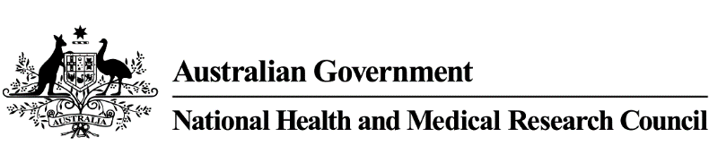



**NHMRC**

**Human Research Ethics Committee (HREC) Member Profile**

**Date: Institution name:**

| **Name** | **Category they represent**  ***(NS 5.1.30)*** | **Gender**  ***(NS 5.1.29)*** | **Institutional or non-institutional**  ***(NS 5.1.29)*** | **Details of appointed member’s experience relevant to their role on the HREC.**  **(eg position and institution listed on current CV)** | **Copy of signed**  **letter of appointment on file**  ***(***[***NS***](https://beta.nhmrc.gov.au/research-policy/ethics/national-statement-ethical-conduct-human-research) ***5.1.36)***  ***(Y/N)*** | **Planned date of induction training**  ***(NS 5.1.28)*** | **Plans for ongoing training in place**  ***(NS 5.2.3(c))***  ***(Y/N)*** |
| --- | --- | --- | --- | --- | --- | --- | --- |
|  |  |  |  |  |  |  |  |
|  |  |  |  |  |  |  |  |
|  |  |  |  |  |  |  |  |
|  |  |  |  |  |  |  |  |
|  |  |  |  |  |  |  |  |
|  |  |  |  |  |  |  |  |
|  |  |  |  |  |  |  |  |
|  |  |  |  |  |  |  |  |
|  |  |  |  |  |  |  |  |
|  |  |  |  |  |  |  |  |
|  |  |  |  |  |  |  |  |
|  |  |  |  |  |  |  |  |
|  |  |  |  |  |  |  |  |
|  |  |  |  |  |  |  |  |
|  |  |  |  |  |  |  |  |
|  |  |  |  |  |  |  |  |
|  |  |  |  |  |  |  |  |
|  |  |  |  |  |  |  |  |
|  |  |  |  |  |  |  |  |
|  |  |  |  |  |  |  |  |
|  |  |  |  |  |  |  |  |
|  |  |  |  |  |  |  |  |
|  |  |  |  |  |  |  |  |
|  |  |  |  |  |  |  |  |
|  |  |  |  |  |  |  |  |
|  |  |  |  |  |  |  |  |
|  |  |  |  |  |  |  |  |
|  |  |  |  |  |  |  |  |
|  |  |  |  |  |  |  |  |
|  |  |  |  |  |  |  |  |
|  |  |  |  |  |  |  |  |
|  |  |  |  |  |  |  |  |
|  |  |  |  |  |  |  |  |
|  |  |  |  |  |  |  |  |
|  |  |  |  |  |  |  |  |
|  |  |  |  |  |  |  |  |
|  |  |  |  |  |  |  |  |
|  |  |  |  |  |  |  |  |
|  |  |  |  |  |  |  |  |
|  |  |  |  |  |  |  |  |
|  |  |  |  |  |  |  |  |
|  |  |  |  |  |  |  |  |
|  |  |  |  |  |  |  |  |
|  |  |  |  |  |  |  |  |
|  |  |  |  |  |  |  |  |
|  |  |  |  |  |  |  |  |
|  |  |  |  |  |  |  |  |
|  |  |  |  |  |  |  |  |
|  |  |  |  |  |  |  |  |

**Privacy** - NHMRC collects personal information from Human Research Ethics Committees (HRECs) as part of the registration process.

This information is collected on contact details for HRECs and for their organisations, as well as details on HREC membership. Without this personal information, a HREC will not be registered, nor will its registration be maintained.

NHMRC uses this information to contact HRECs and their organisations, to confirm that HRECs and organisations agree to the terms of registration, and/or to verify that HRECs’ appointed members meet the requirements of paragraphs 5.1.29–5.1.31 of the [National Statement on Ethical Conduct in Human Research](https://www.nhmrc.gov.au/about-us/publications/national-statement-ethical-conduct-human-research-2007-updated-2018). HREC contact email addresses that do not include personal names or are already publically available may be provided to external third parties. However, all other access to this information will be limited to NHMRC staff.

By providing this information, HRECs and organisations acknowledge that it will be stored by NHMRC. Further information is provided in the [NHMRC Privacy Policy](https://www.nhmrc.gov.au/privacy) or by emailing [HREC.admin@nhmrc.gov.au](mailto:HREC.admin@nhmrc.gov.au).